**UNIVERSITY OF SCIENCE AND TECHNOLOGY OF HANOI**

Information and Communication Technology Department



**REPORT LABWORK 3**

**Name : Phạm Phú Hưng**

**StudentID : BA12-081**

**Major : Cyber Security**

Ha Noi, May 24th 2024

***I) Analyze Bypass technique***

* *Using ByPass (number of exec stages is 1)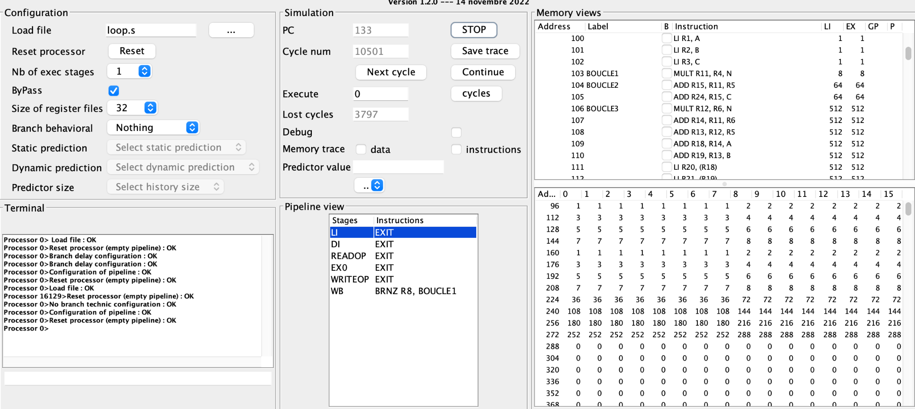*
  + *Cycle number is 10501 and lost cycle is 3797*
* *Without ByPass (number of exec stages is 1)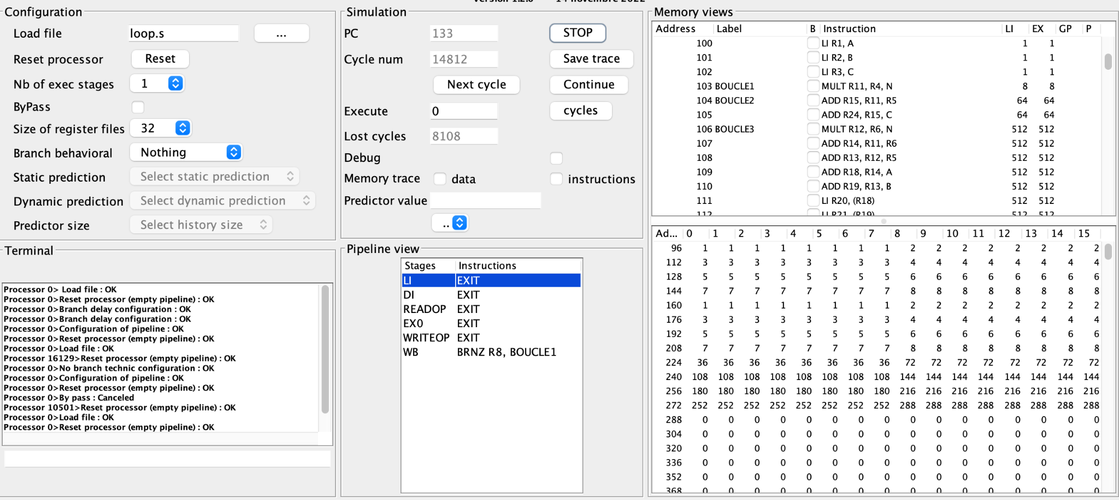*
  + *Cycle number is 14812 and lost cycle is 8108*

*In conclusion, both with and without the bypass, the output is still valid. However, the bypass allows us to skip unnecessary steps in the loop, reducing the number of cycles and the amount of lost cycles compared to the case where the bypass is not there.*

* *ByPass (number of exec stages is 2)*

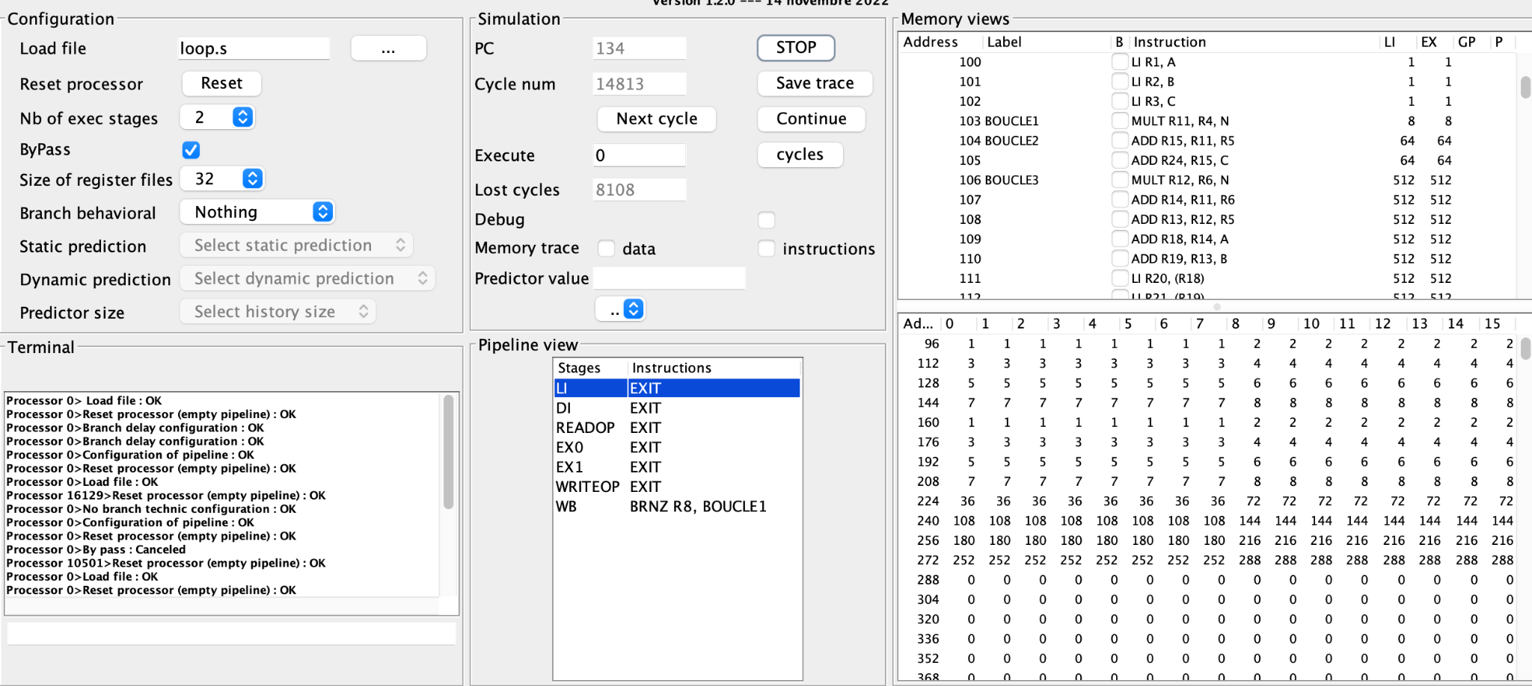

* + *Cycle number is 14813 and lost cycle is 8108*
* *Without ByPass (number of exec stages is 2)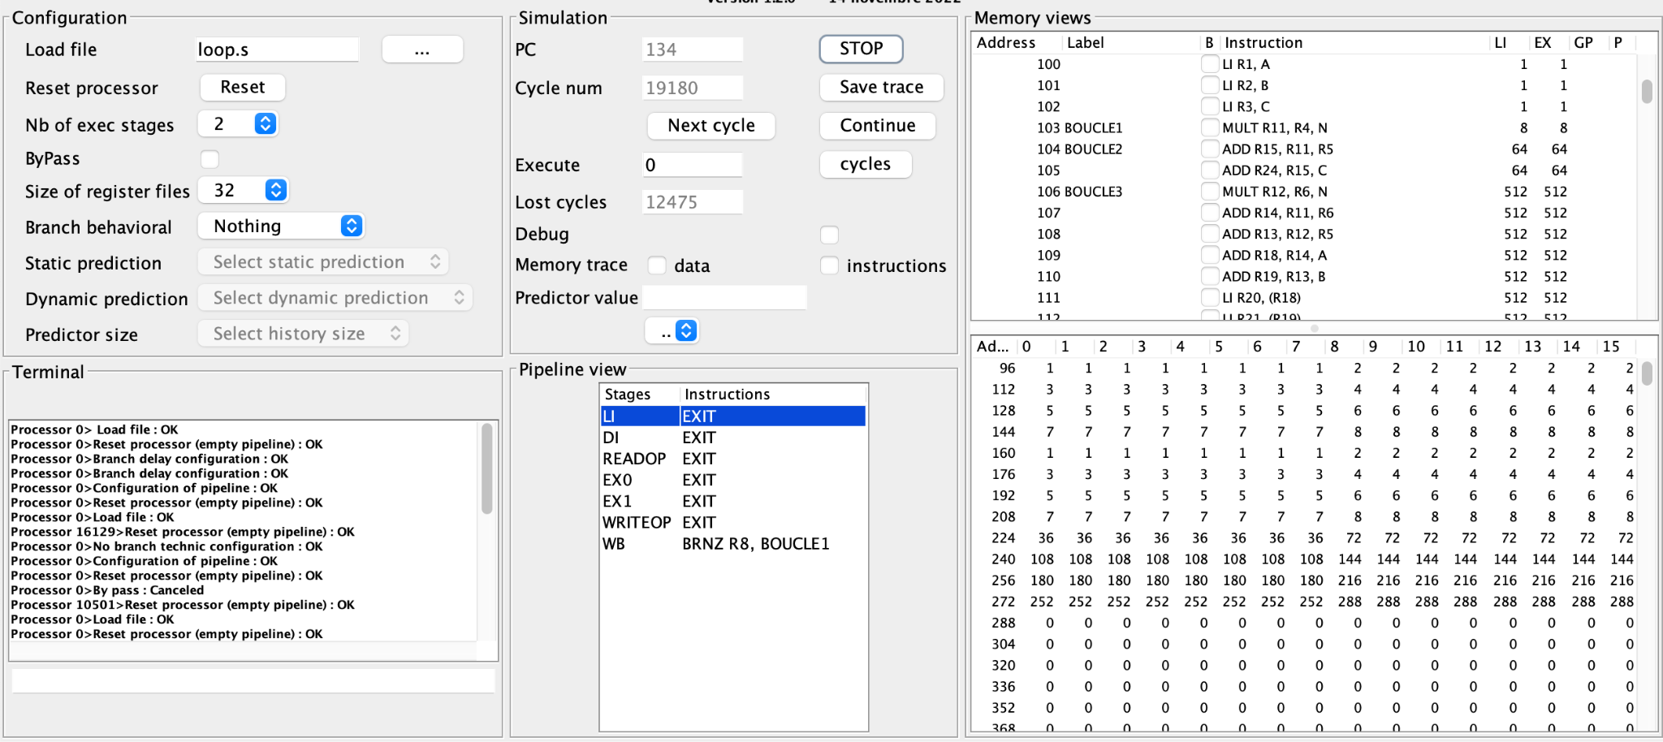*
  + *Cycle number is 19180 and lost cycle is 12475*

*In conclusion, as the number of executive stages increases, so do the cycle number and lost cycle.*

***II. Analyze branch prediction techniques (static)***

* *Output:*

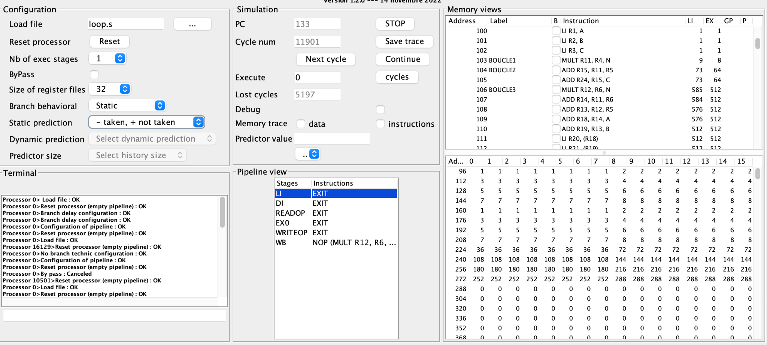

* + *Cycle number is 11901, lost cycle is 5197*
* *Analyze cycle by cycle:*

*We can proceed with the hardware until the branch results are unquestionably known by using static state to assist us regard every branch as untaken. Consider each branch as taken, and as soon as the branch has been decoded and the target address has been calculated, begin fetching and executing the target branch.*

***III. Configure dynamic branch prediction, 1 bit (explain how you configure)***

* *Output:*

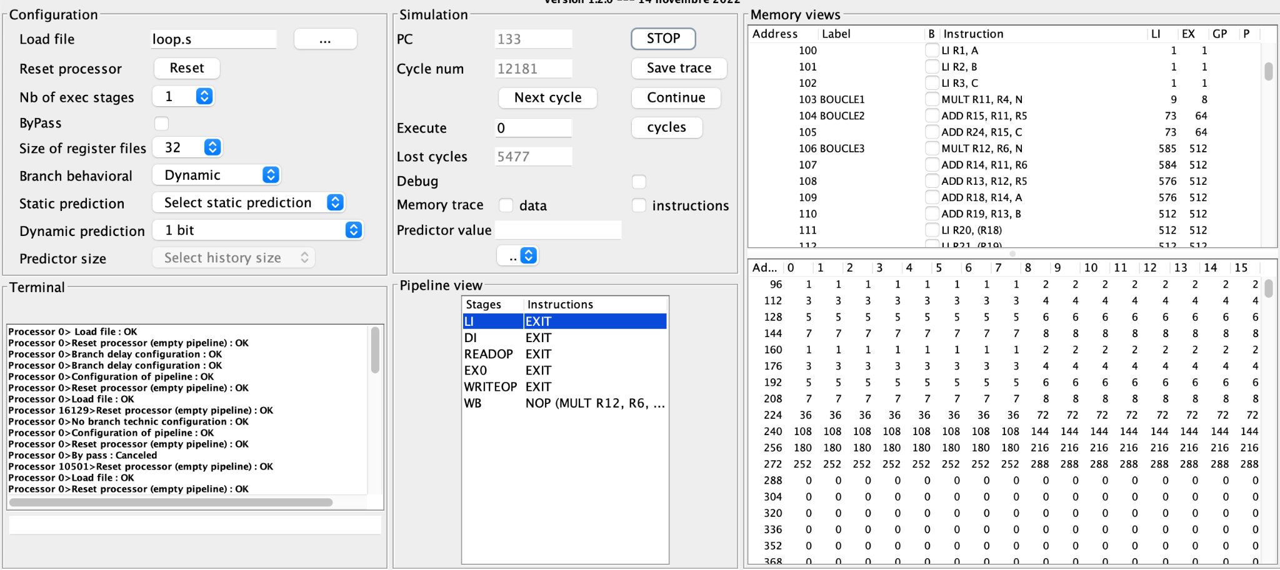

* + *Configuration:* 
    - *Branch behavioral select Dynamic*
    - *Dynamic prediction select 1 bit*
  + *Cycles number is 12181, lost cycles is 5477*
* *Analyze cycle by cycle:*

*Dynamic state depending on the most recent time that the previous branch command was executed or not, and then forecast whether to execute or not the subsequent branch command.*

***IV. Configure dynamic branch prediction, 2 bit (explain how you configure)***

* *Output:*

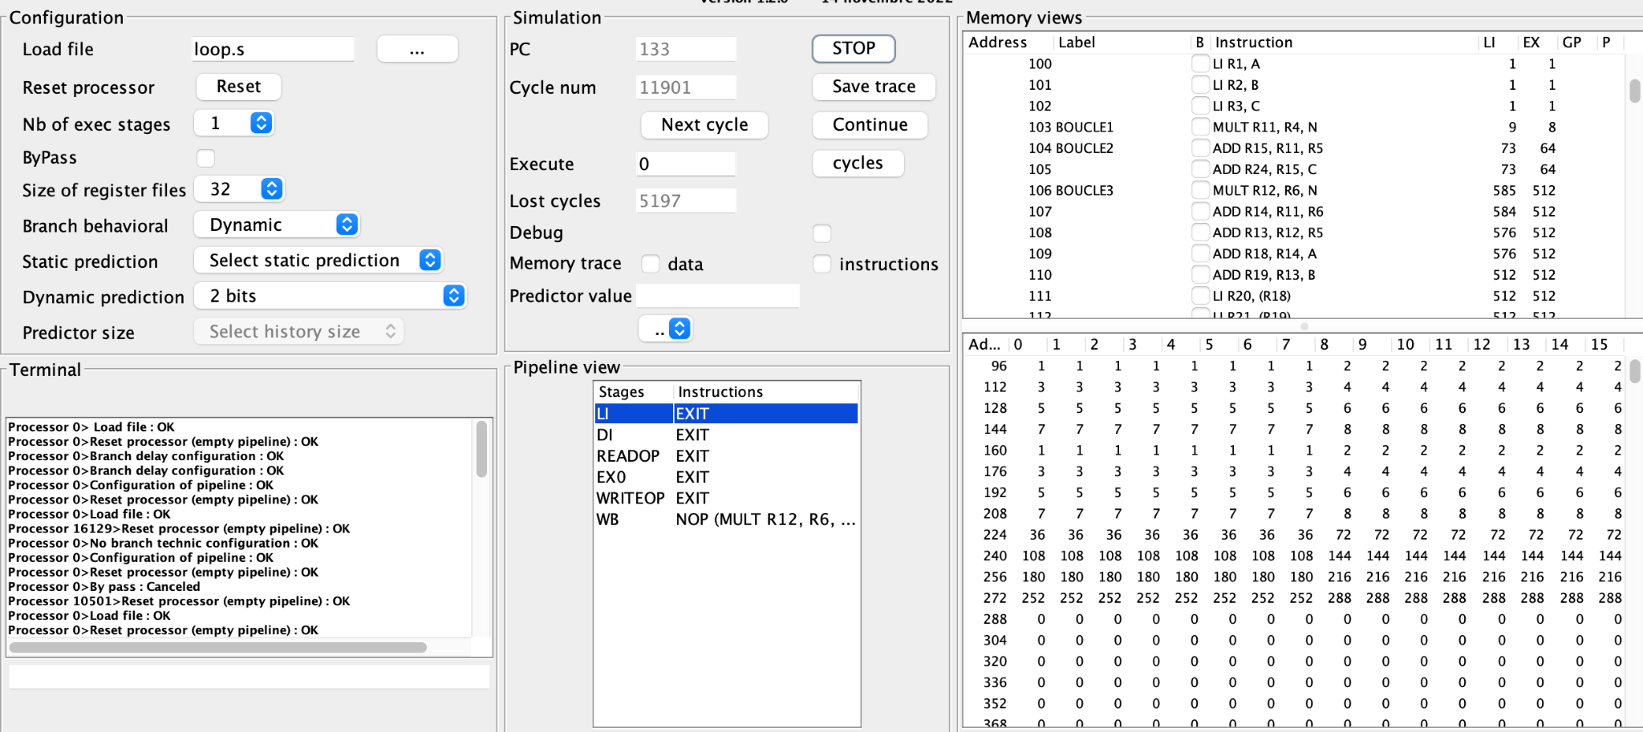

* + *Configuration:* 
    - *Branch behavioral select Dynamic*
    - *Dynamic prediction select 2 bit*
  + *Cycle number is 11901, lost cycles is 5197*
* *Analyze cycle by cycle:*

*Dynamic prediction 2 bit is the same as dynamic prediction 1 bit, but here 2 bit will forecast the nearest 2 times rather than the closest time like 1 bit did.*

***V. Analyze branch prediction techniques (delay branch)***

* *What do you have to do to ensure execution of the code:*
  + *Output to verify the execution:*

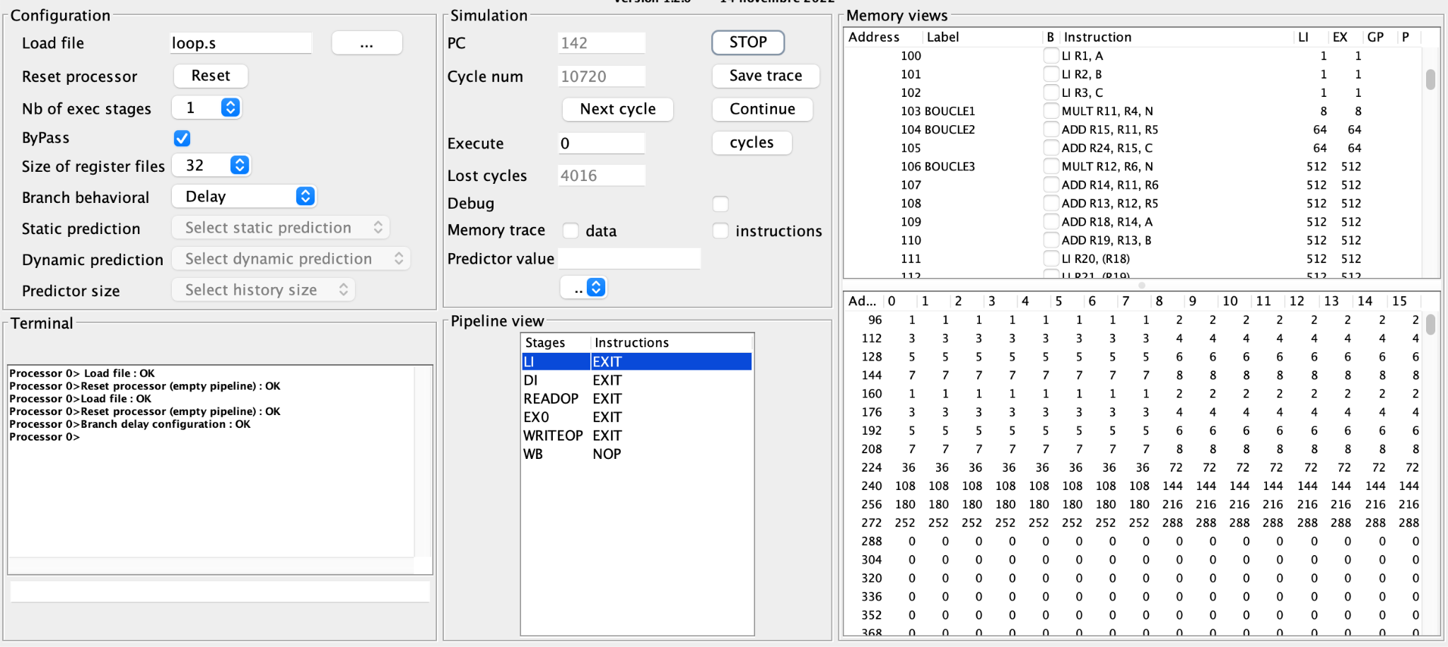

* + *Analyze step by step: Instruction NOP is known while awaiting the branch's conclusion. Regardless of whether the branch is taken or not, this command is followed.*
  + *Modify the number of execution stages   
    